

**LAB FILE**

**Web Programming with Python and JavaScript Lab**

**(SEC 035)**

**SUBMITTED BY:**

**ADEELA AZEEZ**

**SUBMIITED TO:**

**DR. TANVI CHAWLA**

**ROLL NUMBER: 2301010282**

**COURSE: BTECH CSE CORE**

**SECTION: E**

**School of Engineering & Technology**

**K. R. MANGALAM UNIVERSITY**

**Sohna, Haryana 122103, India**

**EXPERIMENT 9**

**DOM**

***Experiment 9.1: Basic DOM implementation***

**Code:**  
<!DOCTYPE html>

<html lang="en">

<head>

    <meta charset="UTF-8">

    <meta name="viewport" content="width=device-width, initial-scale=1.0">

    <title>DOM</title>

    <style>

        .box {

            width: 200px;

            height: 100px;

            background-color: lightgray;

            text-align: center;

            line-height: 100px;

            font-size: 20px;

            margin: 20px;

            transition: all 0.5s ease;

        }

        .hidden {

            display: none;

        }

        .highlight {

            border: 3px dashed red;

            background-color: yellow;

            color: black;

        }

    </style>

</head>

<body>

    <div id="myBox" class="box">Hello</div>

    <button onclick="changeContent()">Change Content</button>

    <button onclick="toggleVisibility()">Toggle Visibility</button>

    <button onclick="createNewElement()">Add New Element</button>

    <script>

        function changeContent() {

            let box = document.getElementById("myBox");

            box.innerHTML = "Text Changed!";

            box.style.color = "white";

            box.style.backgroundColor = "blue";

            box.style.fontSize = "25px";

            box.style.border = "2px solid black";

        }

        function toggleVisibility() {

            let box = document.getElementById("myBox");

            box.classList.toggle("hidden");

        }

        function createNewElement() {

            let newElement = document.createElement("div");

            newElement.innerHTML = "New Element";

            newElement.classList.add("box");

            document.body.appendChild(newElement);

        }

    </script>

</body>

</html>

**Output:**

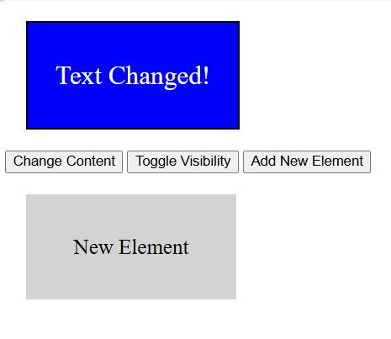

***Experiment 9.2: Live Character Counter***

**Code:**

<textarea id="textArea" maxlength="100"></textarea>

<p>Characters: <span id="charCount">0</span>/100</p>

<script>

const textArea = document.getElementById("textArea");

const charCount = document.getElementById("charCount");

textArea.addEventListener("input", () => {

let count = textArea.value.length;

charCount.textContent = count;

charCount.style.color = count >= 100 ? "red" : "black";

});

</script>

**Output:**

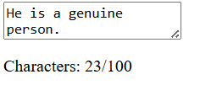

***Experiment 9.3 : Dark Mode Toggle***

**Code:**

<button id="darkModeToggle">Toggle Dark Mode</button>

<script>

const button = document.getElementById("darkModeToggle");

const body = document.body;

button.addEventListener("click", () => {

body.classList.toggle("dark-mode");

localStorage.setItem("darkMode", body.classList.contains("dark-mode"));

});

if (localStorage.getItem("darkMode") === "true") {

body.classList.add("dark-mode");

}

</script>

<style>

.dark-mode {

background-color: black;

color: white; }

</style>

**Output:**

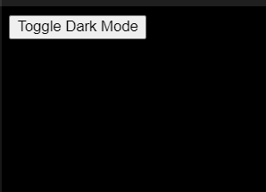

***Experiment 9.4 : Dynamic List Creator***

**Code:**

<input type="text" id="itemInput" placeholder="Enter item">

<button id="addItem">Add Item</button>

<ul id="itemList"></ul>

<script>

const input = document.getElementById("itemInput");

const addButton = document.getElementById("addItem");

const list = document.getElementById("itemList");

addButton.addEventListener("click", () => {

if (input.value.trim() === "") return;

const li = document.createElement("li");

li.textContent = input.value;

const deleteBtn = document.createElement("button");

deleteBtn.textContent = "X";

deleteBtn.style.marginLeft = "10px";

deleteBtn.onclick = () => li.remove();

li.appendChild(deleteBtn);

list.appendChild(li);

input.value = ""; });

</script>

**Output:**

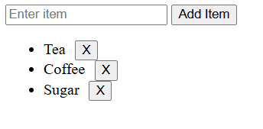

***Experiment 9.5: Image Gallery with Preview***

**Code:**

<img id="preview" src="laptop.jpg" width="300" border="2px solid black">

<div id="thumbnails">

<img src="earphones.png" width="100" border="2px solid black">

<img src="smartphone.jpg" width="100"border="2px solid black">

<img src="watch.jpg" width="100" border="2px solid black">

</div>

<script>

const preview = document.getElementById("preview");

document.getElementById("thumbnails").addEventListener("click", (e) => {

if (e.target.tagName === "IMG") {

preview.src = e.target.src;

}

});

</script>

**Output:**

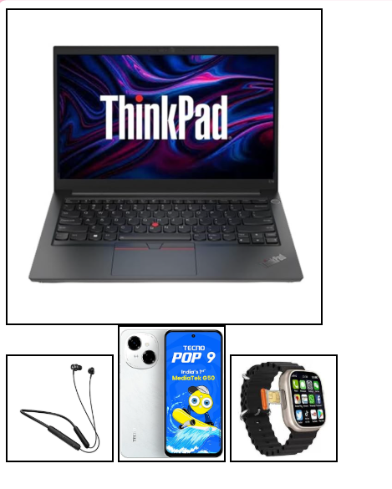

***Experiment 9.6 : Drag and Drop Boxes***

**Code:**

<div id="dragBox" draggable="true">Drag Me</div>

<div id="dropZone">Drop Here</div>

<script>

const dragBox = document.getElementById("dragBox");

const dropZone = document.getElementById("dropZone");

dragBox.addEventListener("dragstart", (e) => {

e.dataTransfer.setData("text", "dragBox");

});

dropZone.addEventListener("dragover", (e) => e.preventDefault());

dropZone.addEventListener("drop", (e) => {

e.preventDefault();

dropZone.appendChild(dragBox);

dropZone.style.backgroundColor = "lightgreen";

});

</script>

<style>

#dragBox {

width: 100px;

height: 100px;

background: blue;

color: white;

text-align: center;

line-height: 100px;

    cursor: grab;

  }

  #dropZone {

    width: 200px;

    height: 200px;

    border: 2px dashed black;

    display: flex;

    align-items: center;

    justify-content: center;

    margin-top: 20px;

  }

</style>

**Output:**

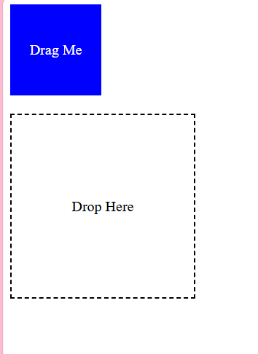 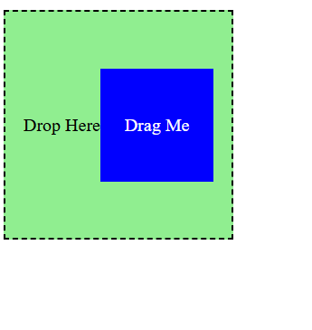

***Experiment 9.7: Custom Context Menu***

**Code:**

<!DOCTYPE html>

<html lang="en">

<head>

  <meta charset="UTF-8">

  <meta name="viewport" content="width=device-width, initial-scale=1.0">

  <title>Custom Context Menu</title>

  <style>

    body {

      font-family: Arial, sans-serif;

      margin: 10px;

      height: 100vh;

      display: flex;

      justify-content: center;

      align-items: center;

      background-color: #f2d2d2;

      flex-wrap: wrap;

    }

    #customMenu {

      position: absolute;

      display: none;

      background: #d5c2c2;

      border: 1px solid #4e4444;

      box-shadow: 0px 4px 6px rgba(0, 0, 0, 0.2);

      z-index: 1000;

    }

    #customMenu ul {

      list-style: none;

      margin: 0;

      padding: 10px 0;

    }

    #customMenu ul li {

      padding: 10px 20px;

      cursor: pointer;

    }

    #customMenu ul li:hover {

      background-color: #d78686;

    }

    img{

        height: 600px;

        width:400px;

        padding: 20px;

        border: 2px solid black;

        margin: 20px;

    }

    h1{

        border: 2px solid #a75c5c;

        padding: 20px;

        margin: auto;

        font-family: 'Times New Roman', Times, serif;

        font-size: 60px;

    }

  </style>

</head>

<body>

    <h1>What would you like to read?</h1>

  <div id="customMenu">

    <ul>

      <li id="option1">A poem</li>

      <li id="option2">A story</li>

      <li id="option3">A quote</li>

    </ul>

  </div>

  <script>

    const customMenu = document.getElementById("customMenu");

    window.addEventListener("contextmenu", (event) => {

      event.preventDefault();

      const { clientX: mouseX, clientY: mouseY } = event;

      customMenu.style.top = `${mouseY}px`;

      customMenu.style.left = `${mouseX}px`;

      customMenu.style.display = "block";

    });

    window.addEventListener("click", () => {

      customMenu.style.display = "none";

    });

    document.getElementById("option1").addEventListener("click", () => {

        const img = document.createElement("img");

        img.src = "poem.jpeg";

        img.alt = "Displayed Image";

        document.body.appendChild(img);

    });

    document.getElementById("option2").addEventListener("click", () => {

        const img = document.createElement("img");

        img.src = "story.jpg";

        img.alt = "Displayed Image";

        document.body.appendChild(img);

    });

    document.getElementById("option3").addEventListener("click", () => {

        const img = document.createElement("img");

        img.src = "quote.jpeg";

        img.alt = "Displayed Image";

        document.body.appendChild(img);

    });

  </script>

</body>

</html>

**Output:**

